Math Analysis CP

WS- Turvy

A Turvy is a drawing which has a caption right-side up and has another caption if you turn it topsy-turvy.

Caption for the picture:



Caption for the picture turned upside-down:



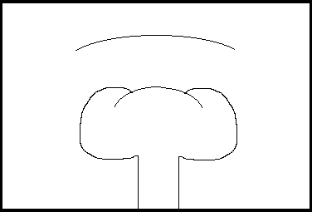To determine the titles to this turvy, solve the 18 problems about sequences and series. Then find the answers to each problem from the choices below. Then replace each numbered blank with the letter corresponding to the answer for that problem.

1. Determine the sum of the infinite series 
2. If the 6th term of an arithmetic sequence is 8 and the 11th term is -2, what is the first term?
3. Find  in the sequence 
4. Determine the sum of the first 8 terms of the geometric sequence 
5. Insert 4 geometric means between 160 and 5. What is the first of these geometric means?
6. Determine the 5th term of the geometric sequence 
7. The 4th term of a geometric sequence is 0.5 and the 6th term is 0.125. Find the common ratio.
8. Determine the sum of the infinite series 
9. A person has 2 parents, 4 grandparents, and 8 great-grandparents, and so on. Determine the number of his ancestors during the 8 generations preceding his own (assuming no duplicates).
10. Determine the sum of the first 25 positive even integers.
11. Determine the sum of the arithmetic series .
12. Insert 4 arithmetic means between 1 and 36. Determine the first of these arithmetic means.
13. If the 7th term of a geometric sequence is 192 and , determine the first term.
14. Determine the sum of the first ten terms of the geometric sequence 
15. Determine the value of  for the sequence 
16. Evaluate .
17. If the 6th term of an arithmetic sequence is 9 and the 11th term is -1, what is the first term?
18. If the first term of an arithmetic sequence is -4 and the 12th term is 32, find the common difference.

ANSWERS:

|  |  |  |  |  |  |  |
| --- | --- | --- | --- | --- | --- | --- |
| a. 19 | b. 3 | c. 8 | d. 81/128 | e. 27 | f. 18 | g. 6500/2187 |
| h. 7.5 | i. 15,345 | j. 17 | k. 510 | l. 1/2, -1/2 | m. 0 | n. 28 |
| o. 36/11 | p. 20,300 | s. 650 | t. 15 | u. 80 | w. 81 | z. -74 |